COMP1562, Lab #2/#3  
Processing programs

|  |  |  |  |
| --- | --- | --- | --- |
| Lecturer | **Mariusz Pelc** | Phone | **020 83318588** |
| Office | **QM366** | e-mail address | **m.pelc@gre.ac.uk** |
| Office hours | **Mon 3-4pm, Wed 9-10pm** |  |  |

**(by M. Pelc and K. McManus)**

**Description:**

**This exercise is mainly focused on tracing the execution of a hypothetical program. Students are supposed to solve all the tasks specified in the section *Tasks*. All calculations / activities will comprise your report content.**

**Learning Outcomes:**

**Main learning outcome here is to learn how processor processes a program and how the execution affects the processor’s registers, memory and I/O devices.**

**Beginning from this week onward you will be using AUTOMATIC MARKING SYSTEM provided for the purpose of automated marking of your weekly tasks solutions. This system launched to provide you with the possibility of checking your results and feedback on regular basis which would not be easily achievable otherwise (like for example manual marking of your weekly uploads).**

**Your group will be able to check results by clicking the “Check Results“ button (any time you want) or view feedback by clicking the “See Fedback” button (this will only be possible when the uploads for the given week are disabled).**

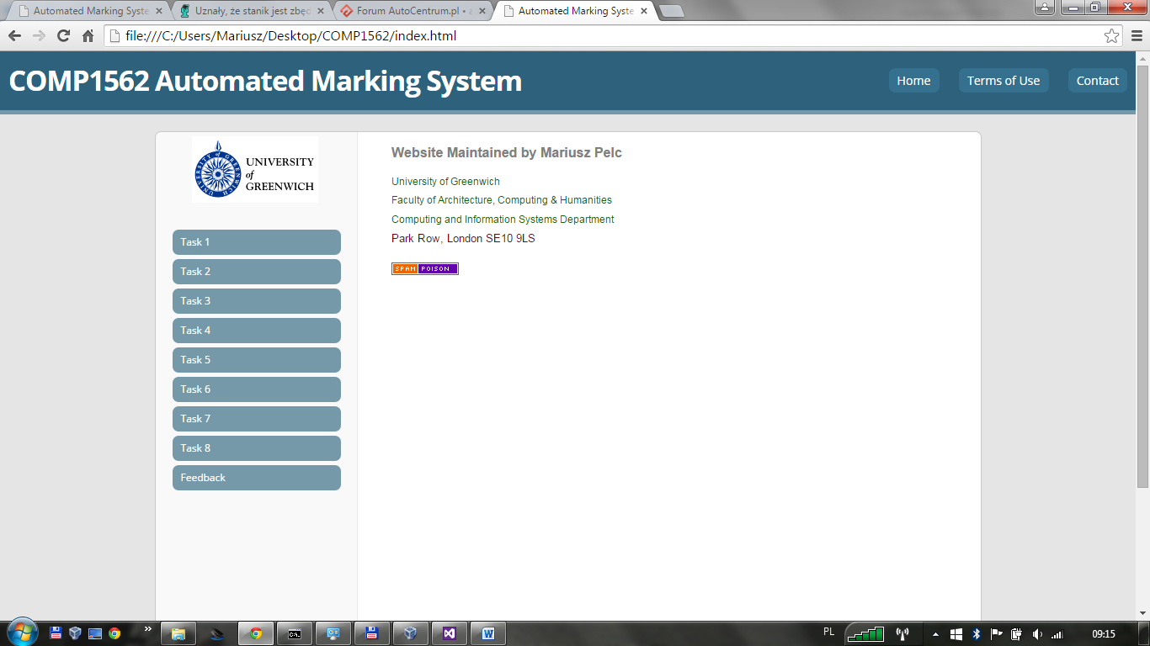

**Your group will have 2 weeks to accomplish this week’s task. This extension is for all of you and its purpose is to make sure you have engaged into group work. Scriptcheck will award a percentage of marks for each correctly entered value, either for registry or calculated time.**

**Tasks:**

* 1. **The hypothetical 16 bit processor in the PowerPoint slides also has two I/O instructions:**

0011 = Load AC from I/O

0101 = Add to AC (add date from the given memory location)

0111 = Store AC to I/O

Your system contains additionally two I/O device buffers at addresses 005h and 006h. Instructions should be placed in the memory locations 300h, 301h and 302h. Memory locations to store / get data are 900,h 901h and 902h. Assume initial values for I/O buffers 005h and 006h to be, respectively, 0001h and 0001h and initial values in the memory locations to be, respectively, 0100h, 0010h and 0001h. All registers values (PC, accumulator and IR, accordingly to the diagram for pseudo code execution) should be updated accordingly. There are 3 steps to be processed (each of the steps comprises of fetch and execute part):

1. Load AC from the device buffer at address 005h.
2. Add contents of memory location 901h.
3. Store AC to device buffer at address 006h.
   1. **Consider a machine with:**
   2. 1k words cache, access time 5ns.
   3. 1M words memory, access time 70ns.
   4. If the data is not in cache then the data is copied from memory.

**Calculate (H is cache success ratio):**

1. Cache miss time.
2. data access time for H=75%
3. data access time for H=85%
4. data access time for H=95%

**Techniques/resources:**

**Solution of Task 1 should be prior done manually, for example using a form similar to the form used to demonstrate pseudo code execution during Lecture 1. This solution should be then included into your weekly upload document and uploaded to the weekly upload area using upload link provided on TeachMat.**

**Solution of Task 2 should also be prior done manually, you need to show results and working in the document you will be then uploading to the weekly upload area.**

**Once you think you are ready to check your results, you need to use the website:**

[**http://scriptcheck.cms.gre.ac.uk**](http://scriptcheck.cms.gre.ac.uk)**/COMP1562**

**Click “Task 1” link and fill in all the text boxes and then click the “Check Results” button. The system will check you solutions and will display percentage reflecting their correctness. You will also be able to check the whole feedback after the upload deadline.**

**Enter your results into corresponding text boxes. Please mind that MUST enter HEXADECIMAL values into the text boxes.**

**Upload button has not yet been enabled.**

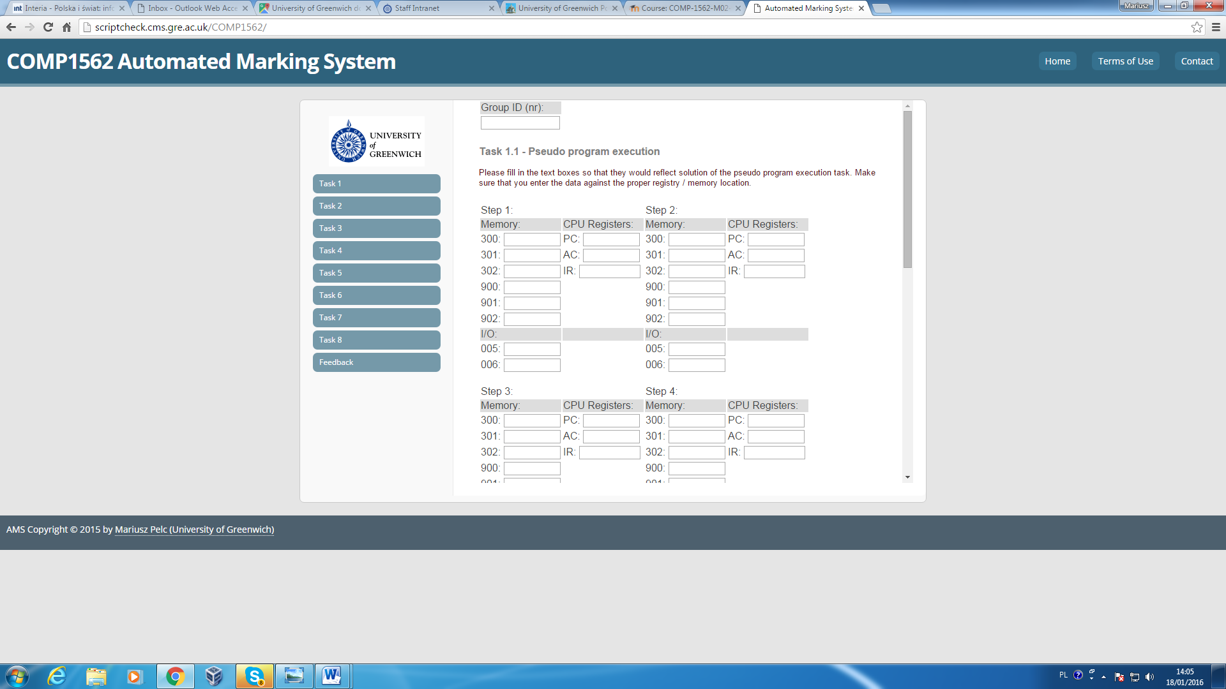

**Marking:**

**The solutions will be marking in the range 0-100%.**

**Deadline:**

**The solutions should be delivered within 2 week from the lab date.**